Klasa IIIa i IIIb - dzieci powtarzają słownictwo, które pojawiło się na zajęciach od początku roku. Proszę również o wykonanie ćwiczeń powtórkowych zamieszczonych poniżej. Pozdrawiam. :)
1 Przeczytaj i dopasuj. Read and match.
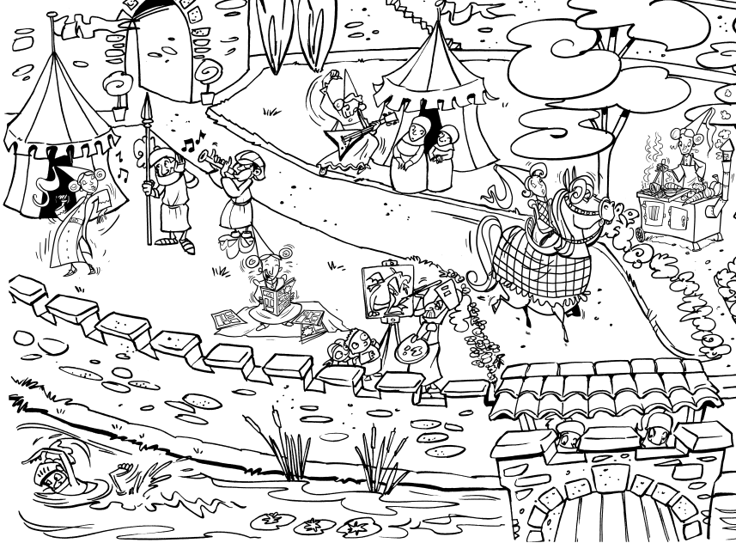 | She likes reading.  He likes painting.  He likes swimming.  She likes dancing.  She likes cooking.
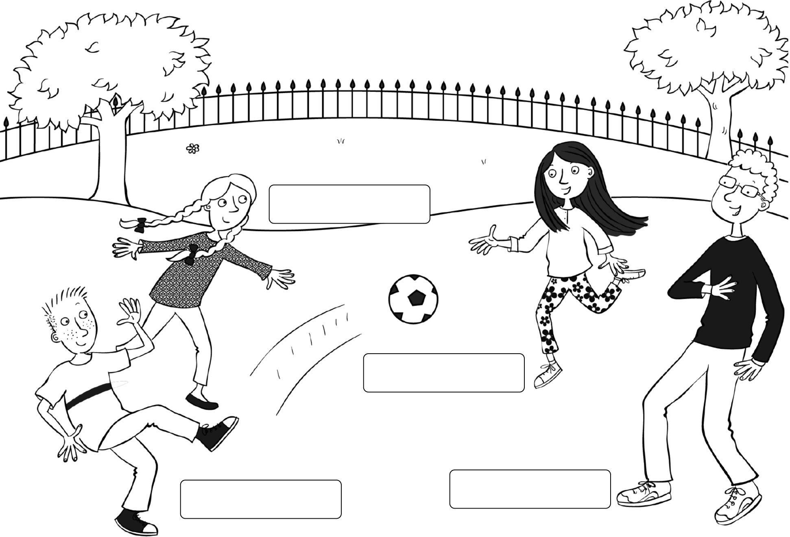
2 Przeczytaj i napisz imiona. Read and write the names.
This is a photo of my four friends. They are in the park. Lisa has got braids. She’s 11 years old. That’s Liam. He’s funny. He’s got short hair. He hasn’t got glasses but he’s got freckles. Anna is here. She’s got long, straight hair. Bill has got curly hair. He’s got glasses. I like my friends.
3 Przeczytaj i napisz, czy zdania są prawdziwe (T), czy fałszywe (F). Read and write true (T) or false (F).
My Blog – by Anna  This is my favourite character.  He's a wizard and his name's Merlin.  He lives in a castle. He likes playing  the guitar and listening to music,  but he doesn't like cooking or dancing.  His favourite hobby is horse riding.  He's got long, grey hair and  he's got blue eyes. He hasn't got glasses. | 1 Merlin is a witch.  2 He lives in a castle.  3 He likes listening to music.  4 He doesn't like horse riding.  5 He's got grey hair.  6 He's got glasses

1 Uzupełnij zdania. Complete the sentences.
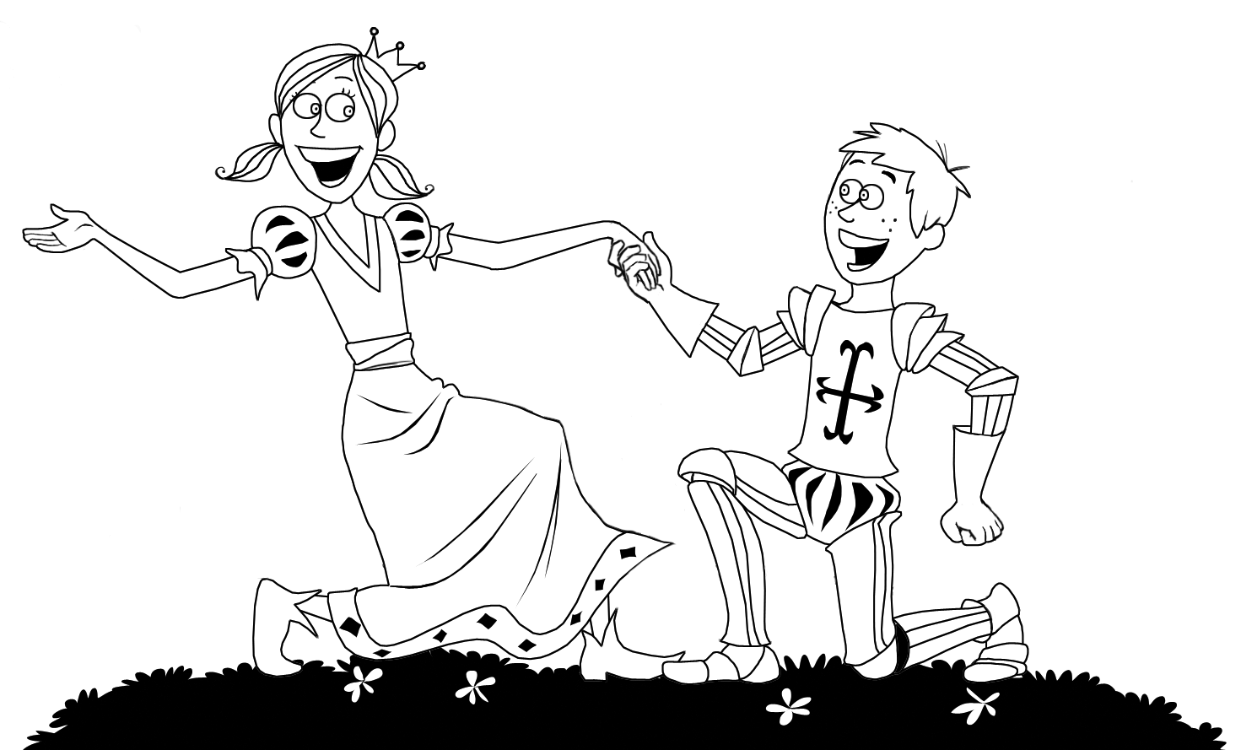 | Her Katy. She’s a .  She’s got hair.  William. .
2 Popatrz i napisz. Look and write.
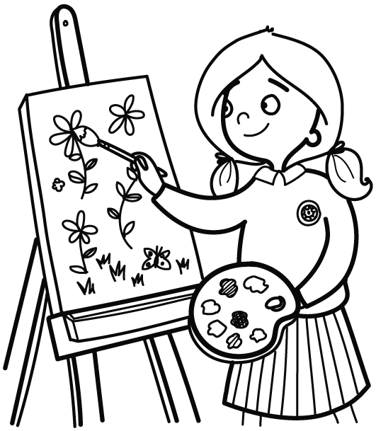 | 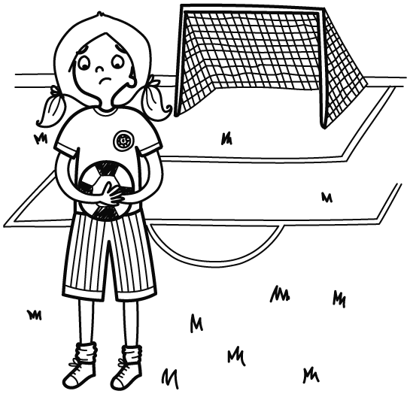
 | 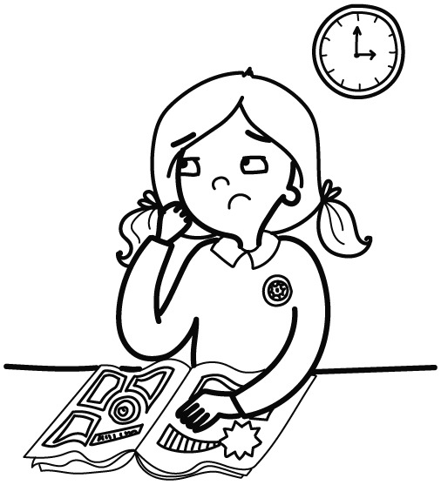
I like but .
I and .
3 Napisz pięć zdań o sobie. Write 5 sentences about yourself.
Name
Hobbies you like and
don’t like
Describe yourself

